**Finding Restaurants near me using Google API in Alexa**

Problem Statement:

Call google API from amazon skill set to help the customer in their day to day needs

Objective:

Create an Amazon skill set that will interact with Google API and get the customer the restaurants near by to them and allow them to call them or provide them the restaurant phone number to call them

Application Flow:

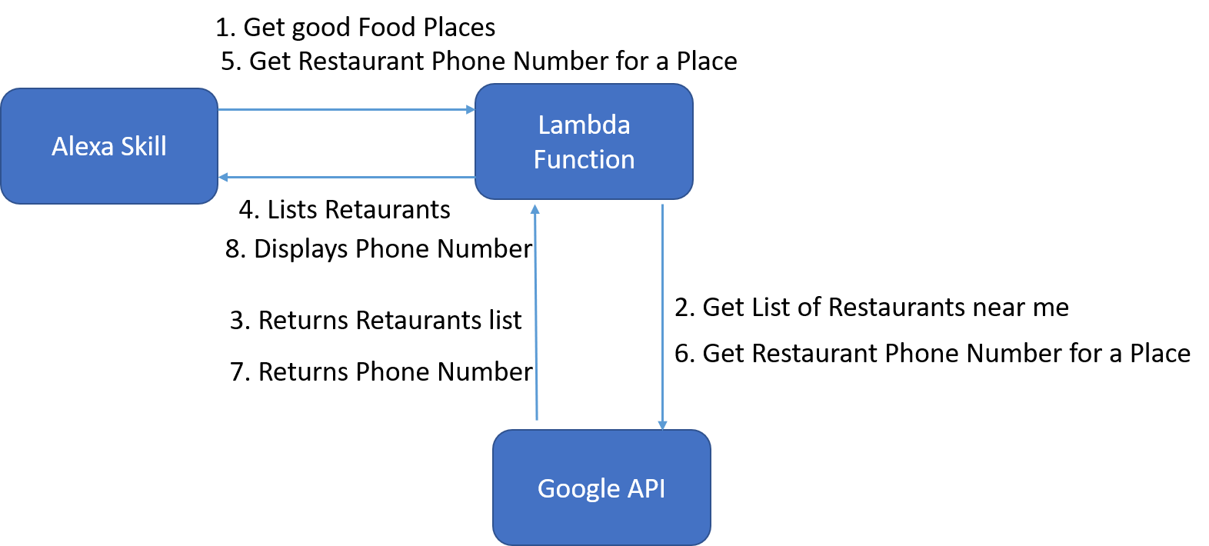

Future Scope:

1. Call Twillio API to make call to the member phone number instead of displaying phone number from google API. Twillio API is not open sourced need to be purchase.
2. Expand the use case for different types of places like Hospital, Grocery shops, car rental etc.
3. Storing Customer preference in a backend database using rest service so that Alexa can proactively tell me “For past three time you went with Taco Bell for lunch, Would you like to place order than again or do you want to try some other restaurant.”

Development Process:

1. An Alexa Skill has been developed in the Alexa Skill Developer tool
2. An AWS lambda function has been created in python 3.6 for responding to the member voice requests.
3. Google API key is generated to communicate with the Google API from python client.
4. HTTP request are used to communicate between python and google API
5. AWS Lambda ARN is used to link Alexa Skill Set and Lambda Function

Screenshots:

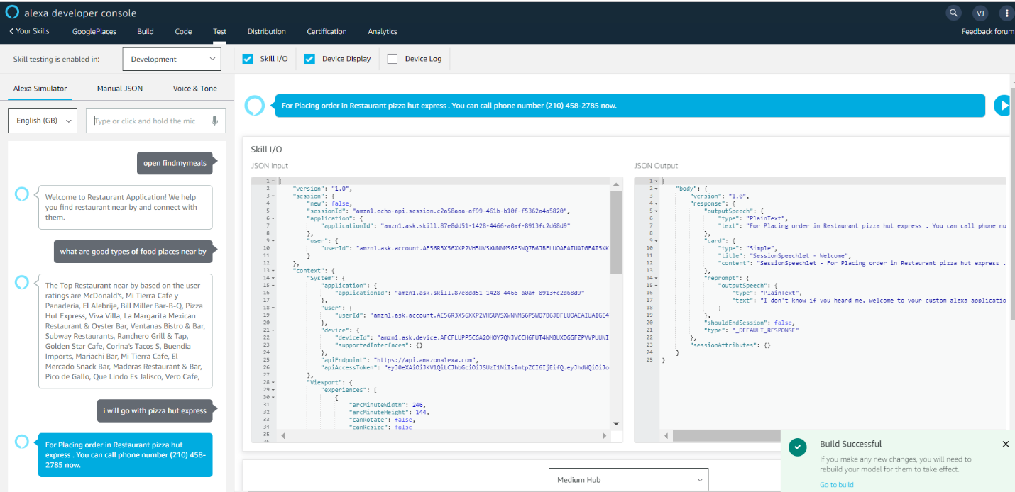

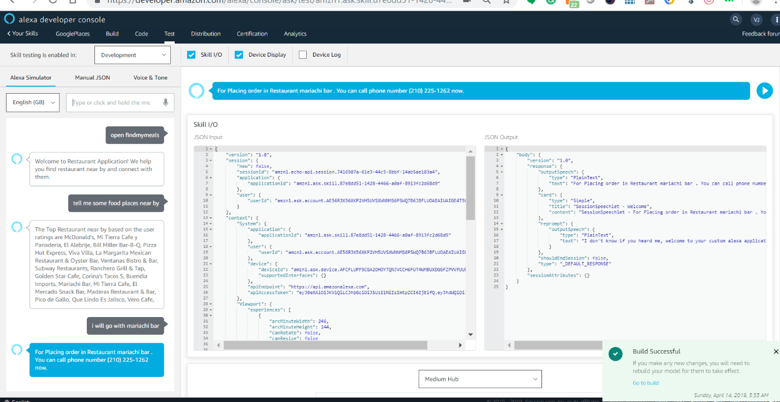

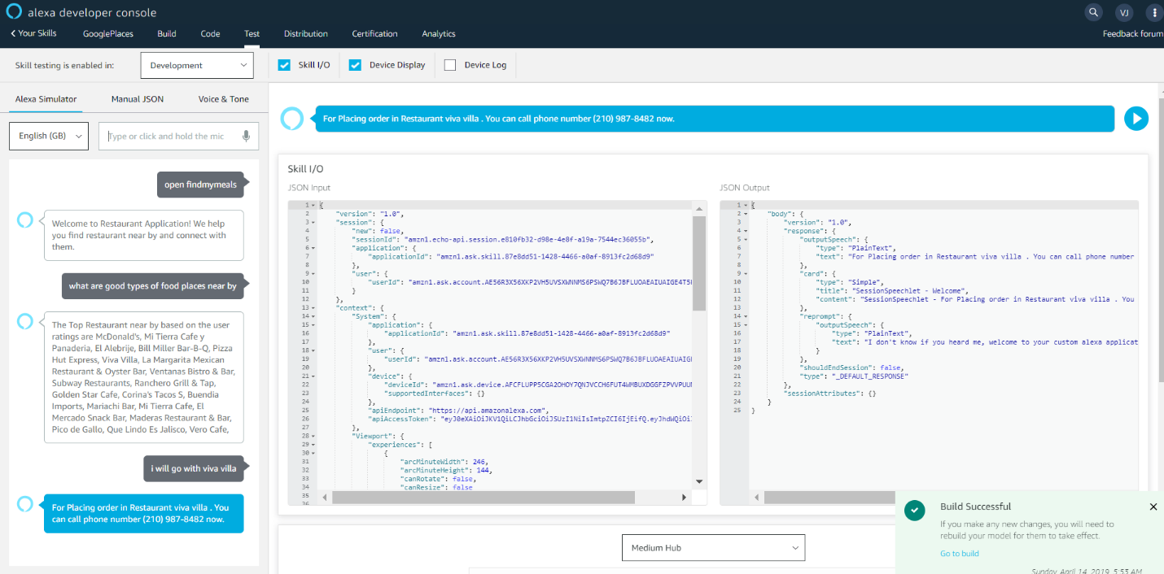

Team Members:

Vinodh Kumaran Jayakumar

Shuvra Chakraborty